Assignment No -: 09

Que 1-: Write A Query That lists each order number followed by the name of the customer who made the order.

kd2_83598>select orders.onum,Customers.Cname,orders.snum from Customers,orders
-> where orders.snum=Customers.Snum;
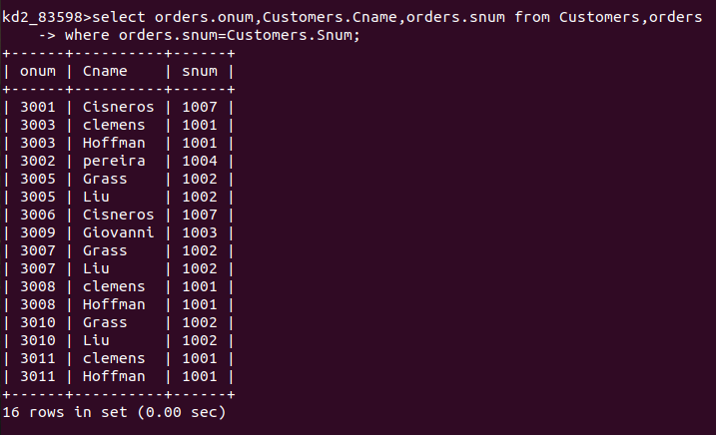

Que 2 -: Write a Query that gives the names of both the salesperson and customer for each order along with order number.

kd2_83598>select salespeople.Sname,Customers.Cname,orders.onum from orders,Customers,salespeople
-> where salespeople.Snum=Customers.Snum and
-> Customers.Snum=orders.Snum;
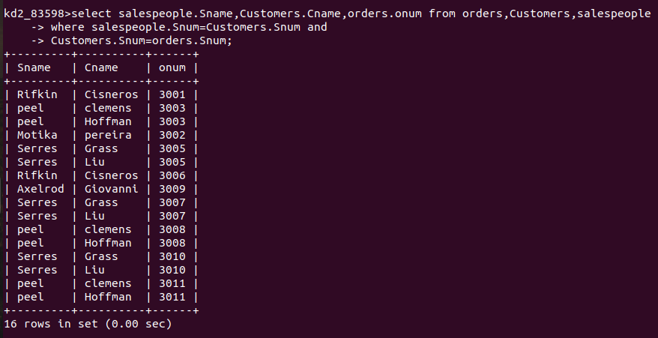

Que 3 -: Write A query that produces all customers Serviced by Salespeople with a Commission above 12%.output the customers Name,The Salesperson Name, and The Salesperson’s Rate of Commission.

kd2_83598>select Customers.Cname,salespeople.Sname,salespeople.comm "Salespeople Commission Rate" from Customers,salespeople
-> where salespeople.Snum=Customers.Snum and
-> salespeople.comm>0.12;

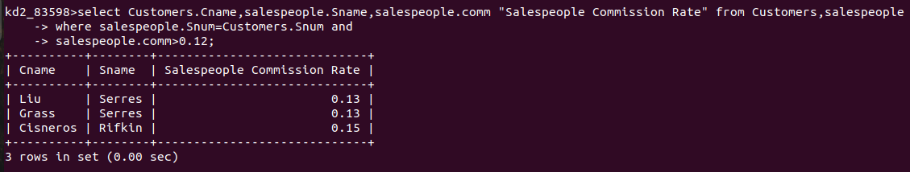
Que 4-: Write a Query that Calculates the amount of the salesperson’s commission on each order by a customer with a rating above 100.

kd2_83598>select orders.onum,orders.amt*salespeople.comm "Commission" from orders,Customers,salespeople
-> where salespeople.Snum=Customers.Snum and
-> Customers.Snum=orders.snum and
-> rating>100;
